Journal of School Violence

**Critical Elements Contributing to Public School Violence in the United States and Efficient Methods for Violence Reduction: Analysis of the School Survey on Crime and Safety for 2010**

Kyle Baylousa, Jesse Lobenhoferb, Juliene Hindsc and Chris Helenekd

a Undergraduate in the Department of Biomedical Engineering, Stony Brook University, Stony Brook, United States;

b Undergraduate in the Department of Biomedical Engineering, Stony Brook University, Stony Brook, United States;

c Undergraduate in the Department of Biomedical Engineering, Stony Brook University, Stony Brook, United States;

d Undergraduate in the Department of Biomedical Engineering, Stony Brook University, Stony Brook, United States

Received May 10th, 2019; revised May 15th; accepted May 16th, 2019

___________________________________________________________________________

For inquires or correspondence, please contact:

Kyle Baylous

1 Josephine Blvd., Shoreham NY

[kyle.baylous@stonybrook.edu](mailto:kyle.baylous@stonybrook.edu)

631-821-3010

________________________________________________________________

**Critical Elements Contributing to Public School Violence in the United States and Efficient Methods for Violence Reduction: Analysis of the School Survey on Crime and Safety for 2010**

**Abstract**

School violence in American public schools has been a common component of the academic environment that not only makes students and faculty feel uncomfortable on school grounds but diminishes the likelihood of student success. Previous research findings suggest that cooperative behavior in high schools is reliant on school size and that school climate and student attendance improve disorder and student learning, while the prevalence of force within the school environment makes it less safe. In order for America’s youth to fulfill their academic potential, schools must be secure and safe. In order to analyze school characteristics that are contributing to school violence and discuss possible methods for violence reduction, the 2009-10 School Survey on Crime and Safety (SSOCS:2010) was examined. The experiment conducted was an observational study that concerned analyzing data from a population of primary, middle, high, and combined schools that represented all American public schools within this range. The subjects for this experiment were public schools in the United States that were selected following the guidelines created by the authors of SSOCS:2010. To address the research question of whether or not it was possible to effectively determine the most significant contributing factors to school violence based on a survey such as SSOCS:2010, results deemed significant and non-significant were all considered and examined. On average, the number of violent incidents recorded was highest in schools that reported having security guards armed with firearms. Regarding urbanicity, the average number of violent incidents recorded was highest in city schools and in schools having 50% or less White enrollment. Also, schools having 0-25% parent volunteers had a drastically larger number of violent incidents on average compared to other schools concerning this survey item. Schools that reported shootings had many common characteristics with respect to the independent predictor variables studied, including about 83% of such schools having armed guards. School size, percent white enrollment, parent participation in parent-teacher conferences, parent volunteer participation and total number of security guards were found as the most predictive and critical elements contributing to school violence among all variables examined. Overall, emphasis on just one of the three categories of school characteristics examined cannot end the escalation of school violence in itself. Instead, it may take a combination and fine balance of these elements and perhaps many more to efficiently prevent high numbers of violent school incidents from occurring.

**KEYWORDS**. Public schools, school violence, school safety, disorder, security, parent involvement

# Introduction

Violence in American public schools has been an incredibly common component of the academic environment, occurring often and impacting the lives of students, teachers and faculty that encounter it. The occurrence of school violence in primary and secondary schools within the United States and factors that may significantly contribute to this violence have been common research topics in the last few decades, especially since school violence has remained at a relatively constant level for the past 30 years (Skiba, 2013). Experiments and analyses of specific public-school districts and independent schools themselves around the country have been conducted in order to better understand what is contributing to such violence. Experiments have been conducted by looking at Montgomery County, Maryland high schools and examining relationships between school disturbances and factors including interscholastic sports programs, cooperative behavior and school size (Langbein & Bess, 2002). It was determined that larger schools within the county experienced more disturbances and violence in the school environment, but sports programs helped reduce these disturbances and encouraged appropriate student behavior (Langbein & Bess, 2002). These findings implicated that developing appropriate, cooperative behavior in these high schools was reliant on school size and the fostering of participation in school sports (Langbein & Bess, 2002). An empirical study of New York City’s middle schools was conducted to study school disorder and the deterioration of safe learning environments in regard to poverty, school size, minority status of student populations and school culture (Chen & Weikart, 2008). It was reported that poverty and minority status of student populations effectively predicted school disorder, but the effect of school size in the direction of smaller schools having lower disorder was small (Chen & Weikart, 2008). Also, the findings implied that school climate and student attendance are key factors in improving disorder and improving student learning, while also providing evidence for the conclusion that reduction in school size may not make the student learning environment safer if this measure is applied alone (Chen & Weikart, 2008). Additionally, it has been proposed that school violence occurs as frequently as it does due to three main points agreed upon by researchers who have analyzed empirical data, noted everyday observations of American schools, and even recorded the personal stories of school shooters. These points are that schools act as places of symbolic microaggression and coercion where force is the commanding factor, that schools often don’t meet expectations set forth by students hoping to find places of creativity and friendship, and lastly, that suburban schools are seen as places of extreme individualism where students can go against social conformities and figure out who they truly are (Warnick, Kim, & Robinson, 2015). Most importantly, the study suggests that the more tightly controlled schools are regarding the prevalence of force, the less safe the school environment becomes (Warnick et al., 2015). This conclusion supports the idea that schools should be more centered around its students and that they should limit policies and implementations that can be portrayed as actions to exercise pure domination and control (Warnick et al., 2015).

Although past studies have focused on analyzing school violence on a small scale by focusing on specific districts and proposing explanations as to why American school violence is so prevalent, it is not clear what factors or characteristics of primary and secondary American public schools are contributing most significantly to school violence on a national level. Previous studies have failed to acknowledge many detailed aspects of American primary, middle, high and combined schools together in order to figure out what factors and trends are most notable in influencing school violence with respect to areas like security measures taken, school demographics, and parent involvement at school. The analysis of schools that represent the entire U.S. school population, with respect to the research focus mentioned previously, instead of specific schools or districts in certain states and counties, would certainly provide the necessary evidence required to determine what school characteristics, policies and implemented measures are truly working to prevent school violence from occurring. This would benefit the entire population of U.S. primary, middle, high and combined schools since it would provide the necessary information and insight needed to begin restructuring schools that experience large scale violence or to even help schools evaluate if they are at risk of school violence if they are exercising certain measures and policies deemed ineffective from research findings.

One of the core aspects of the school environment that contributes most significantly to student success is safety. In order for the nation’s youth to fulfill their academic potential, schools must be secure and safe for all of those who operate within them. If the learning environment fails to be safe, it is certain that teachers cannot appropriately do their jobs in teaching efficiently, and perhaps more importantly, students may struggle deeply in their ability to learn and grow as young members of this nation. By establishing the characteristics, policies and measures apparent in American primary and secondary schools that have proven most influential in the past in preventing school violence, we can ensure that schools that operate presently and newly established schools of the future will be aware of, monitor and continually update measures taken to address school safety.

In order for the U.S. Department of Education and America’s population of primary, middle, high, and combined schools to start implementing policies and measures to decrease school violence, the key contributors to this violence regarding the areas of security measures, school demographics, and parent involvement must be uncovered. This is precisely the reason why the present study aims to understand the critical elements contributing to American school violence. Overall, the present study aims to address the fundamental question of whether or not the critical variables contributing to school violence can be uncovered from data based on school characteristics, and if so, what those variables may be. Additionally, if such variables are uncovered, their predictive power in determining school violence generally and predicting specific forms of violence, such as school shootings, would be examined.

To effectively analyze these factors and discuss possible methods for violence reduction, the 2009-10 School Survey on Crime and Safety (SSOCS) was examined. The SSOCS is conducted by the National Center for Education Statistics (NCES) for the U.S. Department of Education, and this survey is used to collect crime and safety data from administrators and principals of American public schools that they operate within (Neiman, Murphy, & Thomas, 2012). Upon analyzing the data contained in the survey, relationships between school characteristics and violent incidents can be studied in addition to examining efforts by schools to prevent disorder. The approach taken in the present study involved acquiring the data from SSOCS:2010 from the site of the U.S. Government’s open data sources, which is Data.gov. This approach was taken to address the research question of whether or not it is possible to effectively determine the critical elements contributing to school violence based on a school sampling such as the one contained within SSOCS:2010. Upon extracting this data from the online government catalog, the contained data was put into a file format suitable for the IBM SPSS Statistics software program. The SPSS program was used to examine the dataset and to run the required statistical tests in order to determine what school characteristics significantly predicted school violence. The variables of interest that were examined fell under one of three main categories associated with school characteristics, which were security measures taken by schools, school demographics, and parent involvement in school affairs. After analysis of the school subjects contained within the survey and the characteristics associated with each, it was desired that significant results could help spark new insight into efficient methods for school violence reduction and help schools determine if they are at an increased risk of school violence. Additionally, critical elements contributing to school violence may also be significantly affecting the likelihood of the most violent form of school violence, school shootings. This is another component of school violence that the present study aims to learn more about.

**Methods**

***Design:***

The experiment conducted was an observational study that concerned observing, collecting, and analyzing data from a population of primary, middle, high, and combined schools that represented all American public schools within this range. The experiment consisted of a between-subjects approach to examine these schools. The independent and dependent variables examined were chosen from all of the variables included in the school survey and were considered to be the most relevant to school violence. The dependent variable in this experiment was the total number of violent incidents recorded by schools and this was a continuous variable. Violent incidents recorded included instances such as rape, robbery, physical attacks, theft and vandalism (Neiman et al., 2012). The independent variables examined were broken down into three categories for proper and organized analysis. These categories were security measures taken by schools, school demographics, and parent involvement and participation within the school environment. For security measures, the following independent variables were explored: Guards armed with firearms, school requires visitor check-in, students pass through metal detectors, and the total number of full-time security guards. The latter was recorded as a continuous variable while the rest of the variables in this grouping were recorded as categorical variables based on responses of “Yes” or “No” (Neiman et al., 2012). For school demographics, the following independent variables were explored: School grades offered, school size categories, urbanicity, and percent White enrollment. These variables were all recorded as categorical variables and were specifically considered to be ordinal or ranked data based on the natural order of the categories apparent in each (Neiman et al., 2012). For parent involvement, the following independent variables were explored: Parent participation in parent-teacher conferences and parent volunteers at school. Parent participation and volunteer variables were recorded as categorical, ranked data based on percentages (Neiman et al., 2012).

***Subjects:***

The subjects for this experiment were public schools in the United States that were selected following the guidelines set forth by the creators and authors of SSOCS:2010. The sampling frame for this survey was put together from the 2007-08 Common Core of Data Public Elementary/Secondary School Universe data file (Neiman et al., 2012). This dataset was crucial in determining subjects for the school survey being that it consisted of both fiscal and non-fiscal data that covered all public schools, public school districts and state education agencies in the United States. The SSOCS sampling frame did not include every type of school in the United States since it excluded schools from outlying areas of the United States, Puerto Rico, special education schools and vocational schools (Neiman et al., 2012). Altogether, a stratified sample of about 3,500 regular public schools was chosen for this survey, where sample selection strata were defined by factors such as enrollment size and crossing school level due to the relevance of these variables in relation to school crime and violence determined in previous research (Neiman et al., 2012). Additionally, region and percent White enrollment were also considered as stratification variables. Knowing that not all of the desired schools would provide useful data for analysis, since data collection was in the form of a survey, the minimum required sample size was set at 2,550 completed school surveys for SSOCS:2010 (Neiman et al., 2012). Since the majority of school violence has been reported in middle and high schools, a larger portion of the desired sample was allocated to these school types, and the overall allocation of the four school levels was defined as roughly 650 primary schools, 900 middle schools, 900 high schools, and about 100 combined schools (Neiman et al., 2012). Stratification of the sample selection helped ensure that subgroups were appropriately represented in the sample and improved sampling precision (Neiman et al., 2012). A measure of size calculation based on the sum of the square roots of total enrollment of schools within a certain stratum enabled lower enrollment schools and higher enrollment schools to be represented reasonably as well. After the final sample sizes were determined for the 64 total strata, schools were sorted by White enrollment percentage and region, and then within each stratum, a simple systematic random sample was drawn with a corresponding sampling interval for each (Neiman et al., 2012). Lastly, sample weights were utilized to decrease bias rooted in differences between the responding and nonresponding schools, and so the sample was constructed such that the weighted distribution of responding schools closely resembled the total sample distribution initially (Neiman et al., 2012). Overall, 2,648 schools responded with usable survey data, while almost 780 schools did not respond, and about 50 schools were deemed ineligible after selection. For a more detailed explanation of the U.S. school sample selection, see the 2009-10 School Survey on Crime and Safety Documentation (Neiman et al., 2012).

***Materials:***

To assess the SSOCS:2010 dataset, computers were used by researchers running either Windows or Macintosh operating systems. The catalog containing this specific dataset was the Data.gov online catalog. The SSOCS:2010 data was downloaded from Data.gov to the computer being used, and then the dataset was read by the IBM SPSS Statistics software. All statistical tests and analyses were performed using SPSS. For statistical support, *Discovering Statistics Using IBM SPSS Statistics, 4th Edition*, by Andy Field was utilized. Most importantly, the 2009-10 School Survey on Crime and Safety Documentation PDF was used to understand aspects of the study managed by NCES. This documentation was crucial in understanding the motivation for the data collection, the background of the study, the sample design and implementation, data collection methods, and details regarding the survey questions answered by the subjects of the study (Neiman et al., 2012).

***Data Collection:***

The data was collected in the form of a questionnaire survey sent via mail, and telephone follow ups were included as well (Neiman et al., 2012). Following the district approval for some schools selected by NCES to take part in the survey about five months before it was sent out, letters were sent to the principals of selected schools to inform them about the intentions of the survey questions. These pre-survey letters were sent about one week before the mailing of the questionnaire surveys (Neiman et al., 2012). The survey also included a cover page that fully explained the intentions and importance of school participation in the survey. Survey questions featured in the questionnaire were based on the following topics: School practices and programs, parent and community involvement at school, school security staff, staff training, limitations on crime prevention, frequency of crime and violence at school, number of incidents, disciplinary problems and actions, and lastly, school characteristics. The specific questions featured can be examined in the documentation for SSOCS:2010 (Neiman et al., 2012).

After the mailing of the surveys started in February 2010, which was the start of data collection, letters were sent to the selected schools in efforts to increase participation in the survey and prompt schools to fully complete the survey (Neiman et al., 2012). Several weeks after the mailing of the surveys, a few phases of telephone follow ups commenced. The first follow-up call had the purpose of determining the status of the survey by communicating with the principals, or other school contacts, of the schools who had not yet completed the survey. A few weeks after, second follow up calls were conducted for schools who had still not responded (Neiman et al., 2012). During the time in between follow-ups, principals had more time to complete the survey, while additional questionnaires were sent to schools who misplaced or even failed to receive a questionnaire. Respondents could also complete the survey over the phone during these phases of data collection (Neiman et al., 2012). The interviewers contacting schools over the phone were trained members of the U.S. Census Bureau who collaborated with NCES during this data collection. The last portion of data collection was considered to be the non-response follow-up phase, and this occurred several weeks after the reminder phases. This last period consisted of interviews over the phone to complete the survey and also consisted of fax submission of the survey. This lasted for approximately a month (Neiman et al., 2012). Questionnaire data collection ended in July 2010. More details about questionnaire dispersion and collection can be found in the documentation for SSOCS:2010 (Neiman et al., 2012). The data were processed through editing programs after being key-entered and the completion of a returned questionnaire was determined via computer. Other editing programs used on the data checked data consistency and determined valid value ranges (Neiman et al., 2012). Frequencies of the questionnaire items were checked as well to ensure appropriate values were recorded, and this review included both categorical and numeric variables (Neiman et al., 2012). Once all reviewing was completed, the variables, parameters, and values were all incorporated and coded into a single data file. Additionally, imputation procedures were utilized to create certain values for survey items that had been missing information. Three different imputation methods were used, and these helped generate imputation flag variables for each survey item in the data file (Neiman et al., 2012). The output file was then ready for analysis.

***Data Analysis:***

The data file was obtained from Data.gov and loaded into a computer program for analysis. The computer program used was IBM SPSS Statistics and this was incorporated into the experiment in order to determine significant differences between schools when considering school violence on the basis of certain types of variables. More specifically, all of the variables were examined and organized into categories depending on which survey topic they coincided with generally. There were three types, or categories, of survey topic variables analyzed. The three variable categories, which were the independent variables in the experiment, included, security measures taken by schools, school demographics, and parent involvement in schools. The data file codes for the specific variables studied were: C0250, C0110, C0116, SEC_FT10, FR_LVEL, FR_SIZE, FR_URBAN, PERCWHT, C0198, and C0202. The names of these variables were described previously in depth. The dependent variable that was considered to be the best measure of school violence was the total number of violent school incidents recorded by schools, and the data file code for this was VIOINC10. Since the dependent variable was a continuous variable, normality tests were run and the Shapiro-Wilk statistic was examined to determine the appropriate statistical tests to use. The parametric tests implemented consisted of correlations between continuous variables and a multiple linear regression that incorporated both continuous and categorical data. The multiple regression model was also analyzed using a ROC curve. This was utilized to determine the usefulness of the multiple regression model in predicting school violence based on the variables under study. For nonparametric tests, the Kruskal-Wallis test was implemented when analyzing significant differences between two or more groups of an independent variable, that may be ranked, on the continuous dependent variable of violent incidents recorded. This was crucial in analyzing ordinal categorical data. Also, the Mann-Whitney test was utilized in order to compare differences between two independent variable groups on the continuous dependent variable of violent incidents recorded. This was key in analyzing groups of respondents that gave answers of either “Yes” or “No”. Cluster analysis was used to investigate schools with varying numbers of security guards and helped generate groupings of schools based on this variable. Games-Howell post hoc tests were used to determine significant differences between groups based on the average number of violent school incidents recorded. To effectively determine the most significant contributing factors to school violence based on the survey conducted in 2010, results deemed significant and non-significant were all considered and examined. Also, variables deemed significant were used to screen schools that reported school shootings in order to better understand how the variables contributing to school violence generally may be contributing to school shootings, a particular form of school violence, specifically. The most meaningful results were used to formulate efficient methods for school violence reduction that could be implemented by American public schools such as the ones included in SSOCS:2010.

**Results**

The data for violent incidents recorded was not normally distributed (Shapiro-Wilk, S-W=.45, df=2,648, P<.001). This finding was used to implement the appropriate statistical tests and obtain accurate results concerning the school characteristics under study. On average, the number of violent incidents recorded was significantly higher in schools that had security guards armed with firearms (M=30.93, SD=53.32) than that of schools that did not have armed guards (M=18.6, SD=22.86) on school grounds (Mann-Whitney, U=1.97x105, P<.001, n=1,675). This result is shown in Figure 1.

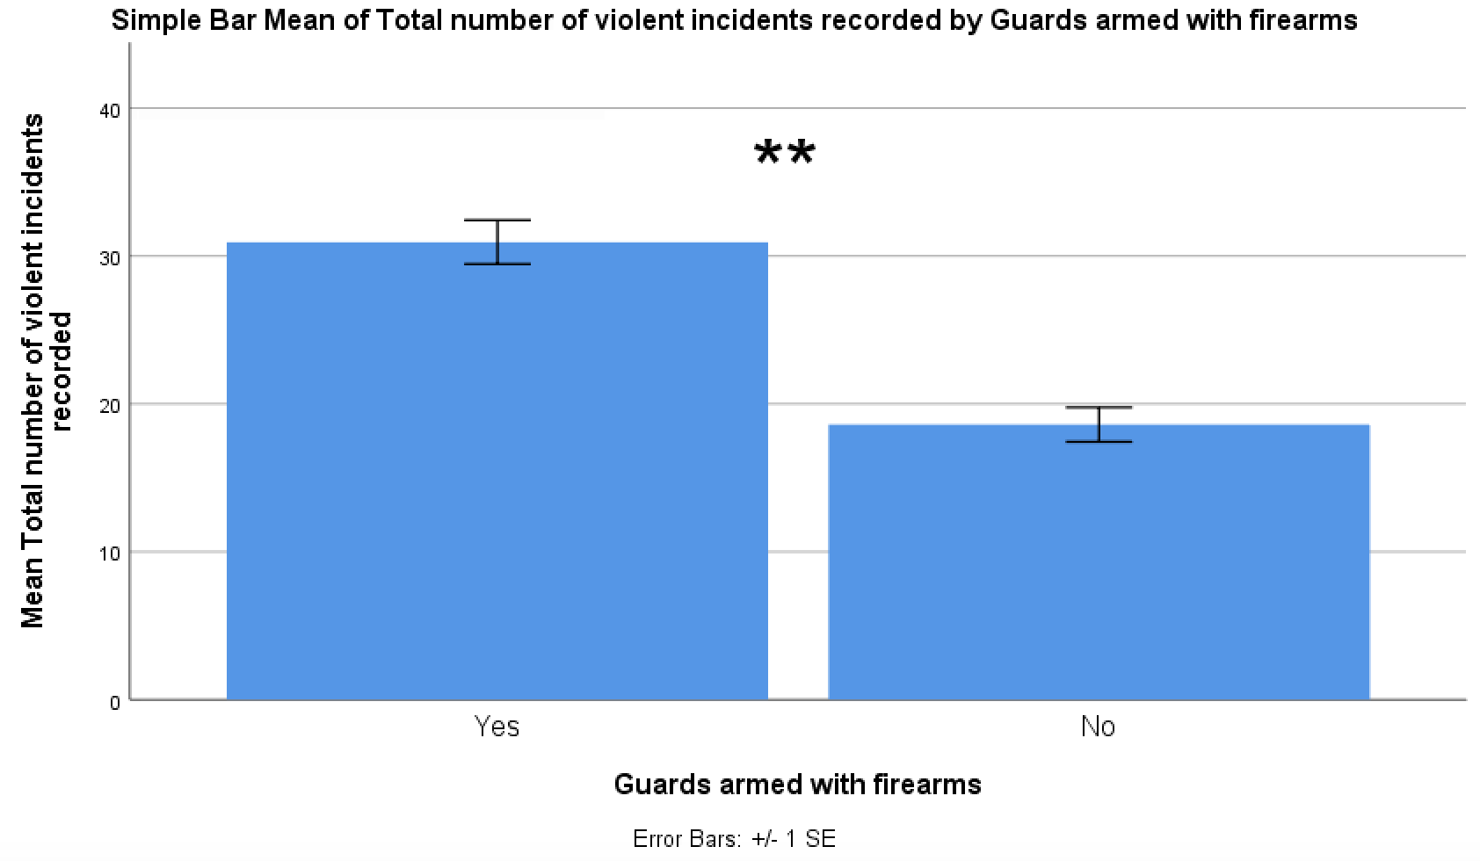

Figure 1. Bar chart showing the average number (±1 SE) of violent incidents recorded for schools that reported having security guards armed with firearms and for schools that did not. Double asterisk (**) indicates P<.001 between group means.

The number of violent incidents recorded, on average, was not significantly higher in schools that required visitor check-in (M=21.95, SD=40.96) compared to that of schools who did not require visitor check-in (M=13, SD=22.45) when entering the school (Mann-Whitney, U=1.1x104, P=.09, N=2,648). On average, the number of violent incidents recorded was significantly higher in schools that had students pass through metal detectors (M=43.89, SD=76.02) than that of schools which did not have students pass through metal detectors (M=21.44, SD=39.69) when entering the school (Mann-Whitney, U=5.5x104, P=.002, N=2,648) as shown in Figure 2.

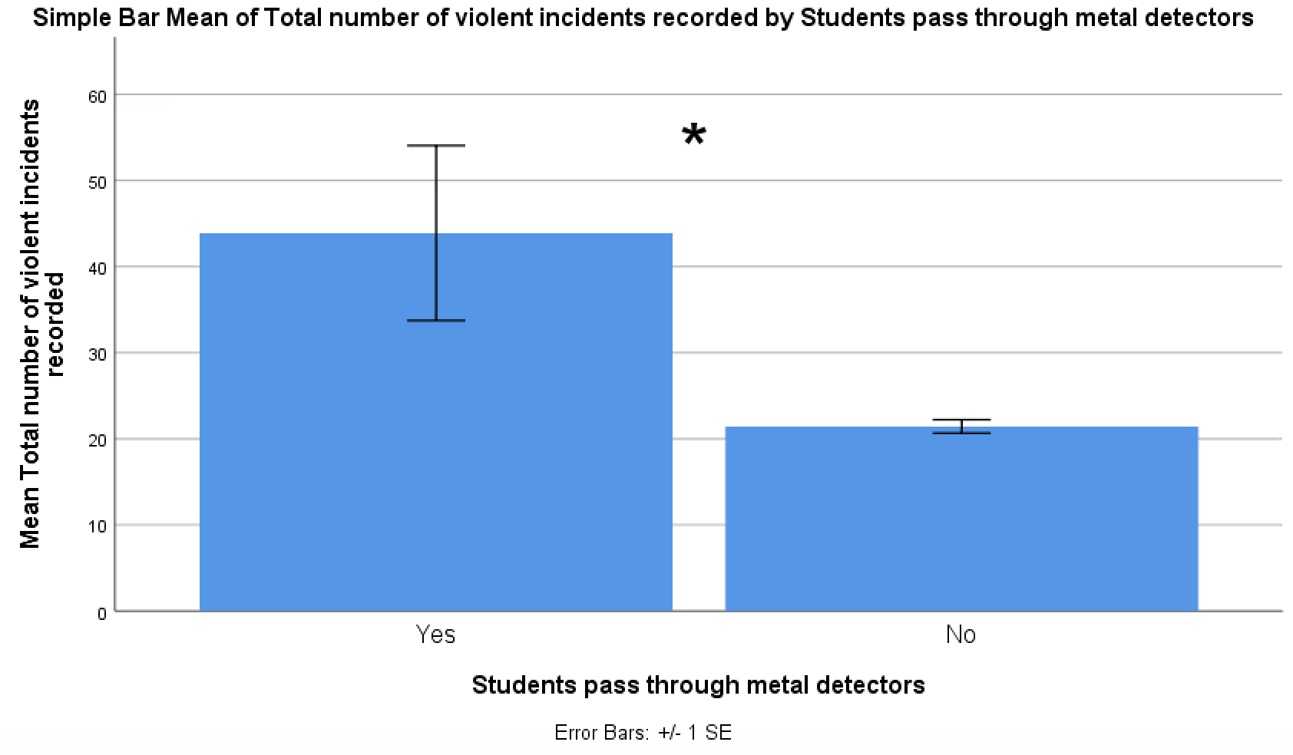

Figure 2. Bar chart showing the average number (±1 SE) of violent incidents recorded for schools that required students to pass through metal detectors and for schools that did not implement this security measure. Single asterisk (*) indicates P<.05 between group means.

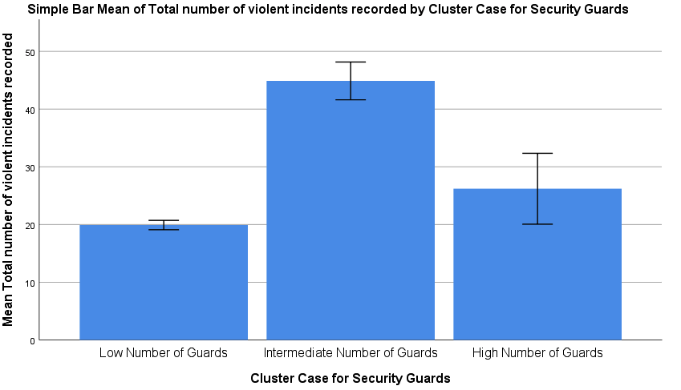When considering the effect of full-time security guard presence on school violence, there was a significant, positive relationship between the two variables (Pearson’s r =.17, BCa CI [.127, .242], P<.001). In other words, as the number of full-time security guards increased in schools, the number of violent incidents recorded increased, or vice versa. However, significant differences were revealed concerning the average number of violent incidents recorded between groups with low, intermediate and high numbers of security guards (Kruskal-Wallis, H=143.54, df=2, P<.001, N=2,648). On average, schools with an intermediate number of guards had much more (M=44.89, SD=3.77) recorded violent incidents than both schools with low numbers of guards (M=19.91, SD=1.13, Games-Howell, P<.001) and schools with high numbers of guards (M=26.2, SD=12.76, Games-Howell, P=.04). Violence within schools with high and low numbers of guards was not very different (Figure 3).

Figure 3. Bar chart showing the average number (±1 SE) of violent incidents recorded for schools that had varying numbers of security guards within the school. Single asterisk (*) indicates P<.05 and double asterisk (**) indicates P<.001 between group means.

*

**

On average, the number of violent incidents recorded was significantly different between different school types (Kruskal-Wallis, H=374.44, df=3, P<.001, N=2,648) where primary schools had much less recorded incidents of school violence (M=10.53, SD=24.32) compared to high schools (M=25.74, SD=41.78) and middle schools (Games-Howell, P<.001) Middle schools (M=27.68, SD=49.26) had much more recorded violent school incidents than that of combined schools (M=11.79, SD=14.68, Games-Howell, P<.001). Additionally, high schools had more recorded violent incidents on average than combined schools (Games-Howell, P<.001), but middle and high schools did not have very different numbers of violent school incidents (Games-Howell, P=.8). With respect to school size, the average number of violent incidents recorded was significantly different between the different school types (Kruskal-Wallis, H=538.38, df=3, P<.001, N=2,648) where schools with less than 300 students enrolled had much less recorded incidents of violence (M=6.21, SD=10.37) than schools with 300 to 499 (M=12.09, SD=17.99), 500 to 999 (M=20.3, SD=37.01) and 1,000 or more (M=36.22, SD=56.17) students enrolled (Games-Howell, P<.001). Additionally, schools with 300 to 499 students had much less violence than schools with larger enrollment numbers, and schools with 1,000 or more had the highest average amount of violent incidents recorded (Figure 4) compared to schools with 500 to 999 students and the other sets of schools with enrollment sizes smaller than that (Games-Howell, P<.001).

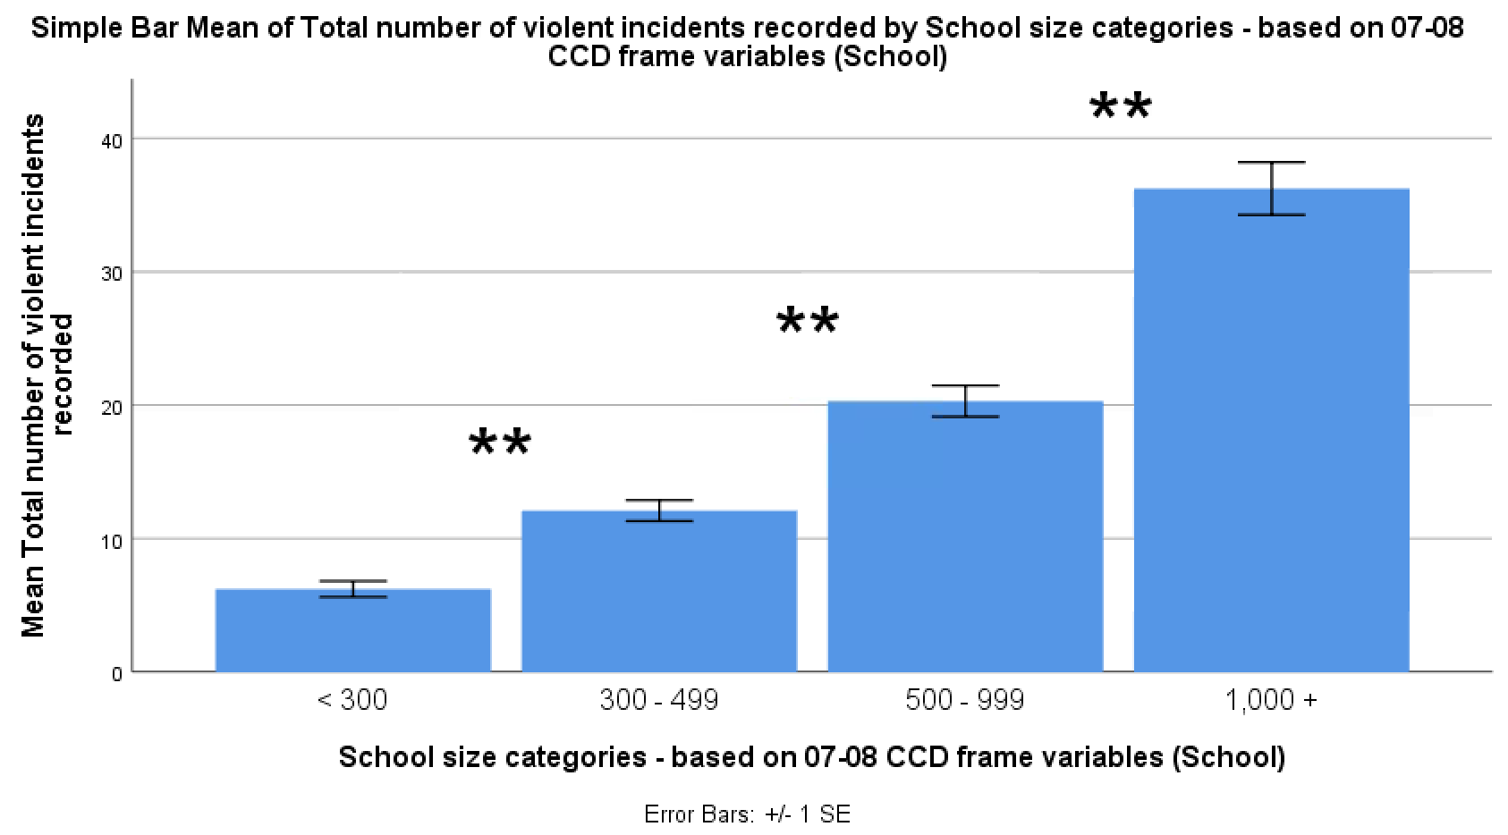

Figure 4. Bar chart showing the average number (±1 SE) of violent incidents recorded for schools that were classified based on enrollment size. Double asterisk (**) indicates P<.001 between group means.

Regarding urbanicity, the average number of violent incidents recorded was significantly different between schools in different regions (Kruskal-Wallis, H=73.66, df=3, P<.001, N=2,648). City schools had a greater number of violent incidents (M=28.09, SD=41.52) than both town (M=17.81, SD=27.3) and rural (M=15.33, SD=29.19) schools (Games-Howell, P<.001) and schools in the suburbs (M=23.84, SD=50.98) had much more recorded violent school incidents than rural schools (Games-Howell, P<.001). Also, town schools experienced a smaller amount of violence than schools in the suburbs (Games-Howell, 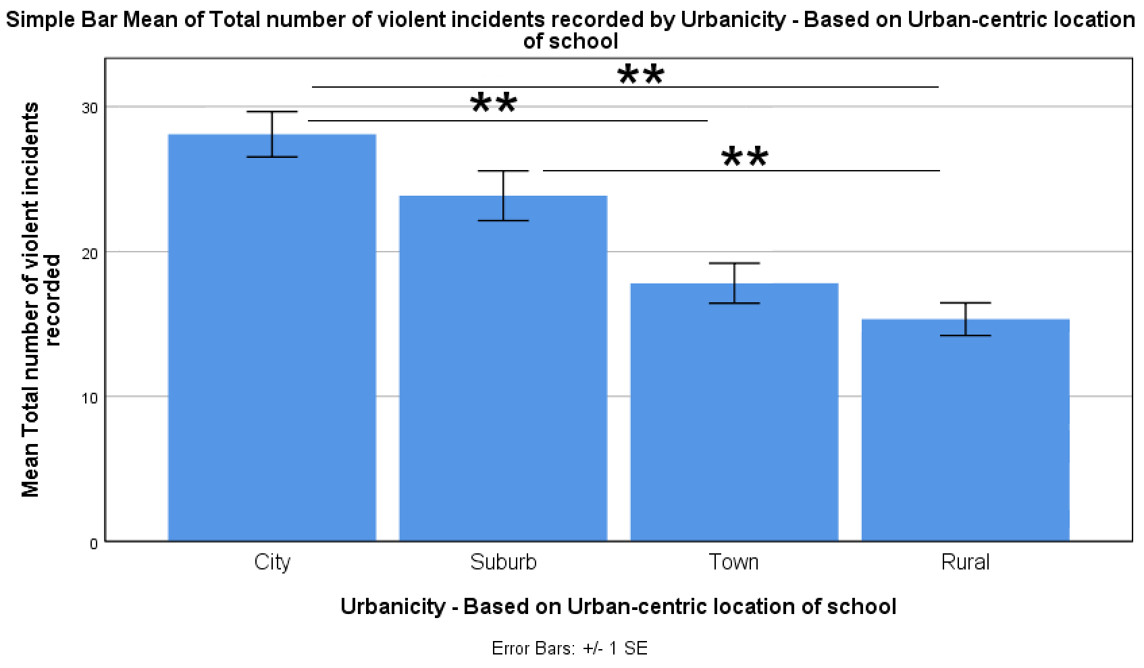P=.03). These results are shown in Figure 5.

Figure 5. Bar chart showing the average number (±1 SE) of violent incidents recorded for schools that were classified based on urbanicity of the school location. Single asterisk (*) indicates P<.05 and double asterisk (**) indicates P<.001 between group means.

*

When considering the percent of White enrollment in schools, the average number of violent incidents recorded was significantly different between schools having different levels of racial mixing (Kruskal-Wallis, H=114.41, df=3, P<.001, N=2,648). On average, schools with 50% or less White enrollment had a greater number of recorded violent incidents (M=30.76, SD=56.98) compared to schools in the 50+ to 80% range (M=22.91, SD=37.41) and the 80+ to 95% range (M=14.46, SD=18.94) (Games-Howell, P<.001). Additionally, schools in the 50+ to 80% White enrollment range experienced much more violence on average compared to schools in the 80+ to 95% range and more than 95% range (M=12.17, SD=20.95) (Games-Howell, P<.001).

On average, the number of violent incidents recorded was significantly different between schools that had varying parent turnout rates during parent-teacher conferences (Kruskal-Wallis, H=228.98, df=4, P<.001, N=2,648). Schools that had 0-25% parent participation had a larger number of violent incidents (M=30.82, SD=37.54) compared to schools that did not offer these conferences (M=21.22, SD=31.87, Games-Howell, P<.001), but was not significantly larger than schools with 76-100% parent participation rates (M=13.52, SD=25.45, Games-Howell, P=.05). Schools that had 26-50% parent participation had a much greater number of violent incidents (M=26.56, SD=39.33) than schools with 76-100% participation (Games-Howell, P<.001). Additionally, recorded violent incidents was much higher in schools with 51-75% participation (M=25.48, SD=57.04) compared to that of schools with 76-100% participation (Games-Howell, P<.001).

When considering parent volunteering at school, the average number of violent incidents recorded was significantly different between schools having different levels of parent volunteering (Kruskal-Wallis, H=212.14, df=4, P<.001, N=2,648). On average, schools having 0-25% parent volunteers had a drastically larger number of violent incidents (M=26.56, SD=48.29) compared to schools that had 26-50% parent volunteers (M=16.23, SD=22.88, Games-Howell, P<.001). Schools having 26-50% parent volunteers had a much higher number of violent incidents than schools with 51-75% parent volunteers (M=11.45, SD=20.34, Games-Howell, P=.04). Also, schools with 76-100% parent participation (M=5.37, SD=9.64) had much lower recorded violent incidents than schools with 51-75% parent volunteers (Games-Howell, P=.006), while schools not offering these volunteer opportunities experienced lower numbers of school violence (M=13.77, SD=25.58) than schools with 0-25% parent volunteers as shown in Figure 6 (Games-Howell, P=.02).

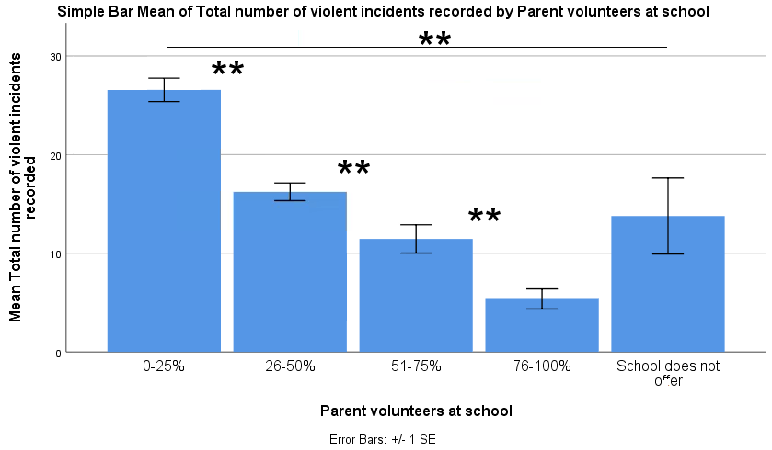

Figure 6. Bar chart showing the average number (±1 SE) of violent incidents recorded for schools that reported varying levels of parent volunteer participation. Single asterisk (*) indicates P<.05 and double asterisk (**) indicates P<.001 between group means.

*

*

*

The multiple linear regression model generated by incorporating all of the previously analyzed variables was a significant fit to the data (F(10,2637)=30.5, P<.001). In terms of the individual predictors, the variables that significantly predicted violent school incidents were school size, percent white enrollment, parent participation in parent-teacher conferences, parent volunteer participation and total number of security guards. The unstandardized and standardized beta values for all individual predictors are shown in Table 1. Also, it was found that the multiple regression model output was a fairly useful predictive model (Figure 7) based on the generated ROC curve when considering the occurrence of school violence (Area=.78, P<.001).

|  |  |  |  |  |
| --- | --- | --- | --- | --- |
|  | B | SE B | β | |
| Constant | 13.47 | 16.52 |  | |
| Guards armed with firearms | 0.61 | 0.77 | 0.02 | |
| School requires visitor check-in | 3.79 | 11.28 | 0.01 | |
| Students pass through metal detectors | -9.03 | 5.46 | -0.03 | |
| Total number of full-time security guards | 0.76 | 0.25 | 0.06* | |
| School grades offered | -0.44 | 1.02 | -0.01 | |
| School size | 8 | 0.91 | 0.19** | |
| Urbanicity | 0.06 | 0.79 | 0.002 | |
| Percent White enrollment | 4.48 | 0.84 | 0.11** |
| Parent participates in parent-teacher conference | -2.39 | 0.75 | -0.06* |
| Parent volunteers at school | -4.14 | 0.89 | -0.09** |
| Note: R2 = .104 (P < .001). *P < .01, **P < .001. |  |  |  |

Table 1. Unstandardized and standardized coefficient values of the multiple regression model along with their respective significance. The multiple regression model was used to predict violent incidents recorded by schools.

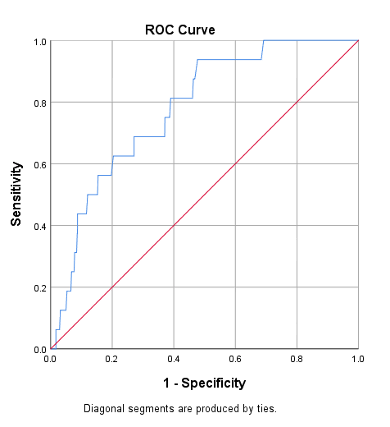

Figure 7. The receiver operating characteristic (ROC) curve used to estimate the reliability of the multiple regression model generated to predict violent incidents occurring in schools.

After analyzing and screening the schools who reported school shootings with respect to the independent predictor variables mentioned thus far, it was found that such schools had many common characteristics. Approximately 83% of schools who experienced shootings had guards armed with firearms within the school, and additionally, over 80% of the schools who experienced shootings did not have students walk through metal detectors. All schools that experienced shootings monitored visitors coming into and out of the school with visitor check-in. Approximately 50% of the schools that experienced shootings did not have any full-time security guards. About 50% of the schools that experienced shootings were high schools, while all of the schools experiencing this violence enrolled 300 to almost 1000 students. Over 66% of the schools that experienced this extreme form of violence were city schools and about 83% of all shootings occurred in schools that had 50% or less White students enrolled. Additionally, about half of the schools that reported shootings had 26-50% parent involvement in parent-teacher conferences and over 80% of shootings occurred in schools reporting that 0-25% of parents volunteer at school.

**Discussion**

Upon analyzing the results derived from the experiment, many of the variables under study proved to be critical elements in predicting school violence. When schools implement armed guards, there is a clear indication of violence increase. Some may question if this is an accurate result since schools experiencing high instances of violence may employ this security measure following the increased levels. However, not only is causality not accurately measured from a result like this, but schools participating in the survey most likely had a set number of armed guards already in place in the years leading up to the survey, yet still reported incredibly high numbers of violence in 2010. Instead, this result likely demonstrates how the school environment is tainted and transformed into an environment where force and coercion are the major factors when security guards with firearms are implemented as a measure to reduce violence. This is consistent with the findings and ideas held by others in the field regarding school violence (Warnick et al., 2015). Equipping security guards with firearms, therefore, is not an efficient measure in reducing school violence.

Schools that required visitor check-in did not see substantial differences in school violence compared to schools who did not implement this type of security measure, and so the usefulness of this security measure in preventing school violence may not be effective. It is likely that schools requiring students to pass through metal detectors experienced substantially larger amounts of violent incidents than schools that didn’t use this security measure because of similar reasons tied to armed guards. The existence of metal detectors on school grounds and being required to pass through them on a daily basis certainly transforms the school environment into a more intense and fiercer environment that is leading to more aggressive behavior. This transformation of the school environment is consistent with the findings of others (Warnick et al., 2015) who investigated school shootings. This security measure did not prove to be efficient in preventing school violence. It was assumed that the total amount of security guards would have a large, negative effect on incidents of school violence. However, the total amount of security guards proved to have a small, positive effect on school violence, contrary to the expectations of this factor on school violence. Again, causality cannot be addressed accurately from this, but it is highly unlikely that the number of violent incidents recorded would have resulted in an increase in the total number of full-time security guards within the time period that the survey was conducted. After looking beyond this correlation, cluster analysis revealed that schools with an intermediate number (5-23 guards) to high number (24-61 guards) of security guards experienced a much greater number of violent incidents in relation to schools having low numbers of security guards (0-4 guards). This result proved to be contrary to the expectations of how this variable would affect school violence, with the specific expectation that more security guards would deter more violence. Instead, the hiring of full-time security guards actually encourages student aggression and, therefore, is not an efficient way of diminishing school violence due to the harsh school environment it creates. This shows how more beneficial school violence prevention solutions need to be explored along with better disciplinary alternatives to suspension and expulsion (Fenning et al., 2012), since current methods are failing.

In consistency with the expectations of the researchers of the present study and the founders of SSOCS:2010 (Neiman et al., 2012), the largest amount of recorded violent incidents were observed in middle and high schools. Although the procedure for the size and representation of the sampling population did cater towards including more of these two school types, it is clear that middle and high schools should be the primary audience for a study such as this and should look to implement efficient polices and measures for violence reduction the quickest. The finding that school size has a profound effect on school violence, where larger schools record much larger numbers of violent incidents, is consistent with others who reported on this factor (Langbein & Bess, 2002) but the effect in the present study was much larger. This finding also generalizes the important effect of this measure to nearly all American primary and secondary schools, not just one district. Some might believe that larger schools would certainly record larger numbers of violent incidents due to the sheer size of the enrollment of the school, and simply saying this would promote the idea that schools of this magnitude may be highly incapable of promoting a safe school environment and controlling what goes on within its walls. This is precisely the reason why developing smaller schools should be a key method in diminishing school violence. When schools enroll 1,000 or more students, it is highly unlikely that they can control the disorder that goes on no matter what types of polices or measures are taken. However, smaller schools not only enhance the personalized experience of school, but also foster a safer learning environment due the increase in efficiency of violence prevention measures on a smaller population of students.

Another key demographic factor that resulted in substantially higher numbers of school violence was the percent White enrollment of schools. This finding most certainly exemplifies the drastic effect of racial tensions on school violence and how race differences represent a major problem within the school environment. Incorporating programs that encourage interaction between students and school cohesion within schools that have a mixed-race enrollment population is essential in reducing school violence and destroying the social schisms that still disrupt and effect the young people of America. Since cities are major locations for the interaction of races, this may be a reason why city schools experienced the largest number of violent incidents compared to other school types based on urbanicity. It cannot be overlooked, however, that city schools may be experiencing such incredible numbers of violence due to the surrounding city environment. It is here that crime and violence flourish most noticeably. Nonetheless, city schools require the most violence reduction and need to reconsider the methods used to prevent it currently.

Parent involvement is a factor that was not included in previous studies focusing on school disorder and disturbances within specific school districts (Chen & Weikart, 2008; Langbein & Bess, 2002), yet this factor proved to be a major contributor to violent school incidents and was more significant than initially expected. When parents did not participate in school conferences or did not actively volunteer within schools, substantially higher numbers of recorded violent school incidents were seen. This is a clear indication that parents have a profound effect on the attitudes of their children and the healthiness of the academic environment itself. When parents fail to involve themselves in the school that they send their children to, it seems that this neglect is acknowledged by students and then transformed into anger, frustration and violence. Not only does this highlight the importance of parent and community involvement in school affairs, but this provides the necessary evidence needed to conclude that the most effective measures and policies regarding school violence do not stem from security but are rooted in promoting parent involvement in school affairs.

The multiple linear regression model generated by incorporating all of the previously analyzed variables accounts for 10.4% of the variance in recorded violent incidents in schools. The model predicted school violence fairly well based off of the variables analyzed within the present study and the most predictive variables were school size, percent white enrollment, parent participation in parent-teacher conferences, parent volunteer participation and total number of security guards. Total number of security guards, school size and percent white enrollment all had positive standardized beta values, which indicates a positive relationship between each of these variables and violent incidents. Specifically, as the total number of security guards, school size and percentage of mixed-race enrollment increased, the larger the number of violent incidents. Parent participation in parent-teacher conferences and parent volunteering both had negative standardized beta values, which indicates a negative relationship between each of these variables and violent incidents. Specifically, as parent involvement, as a percentage, decreased in these variables, the larger the number of violent incidents recorded.

This model could be greatly improved with the incorporation and analysis of other variables contained and represented in the school survey. Nonetheless, school size, percent white enrollment, parent participation in parent-teacher conferences, parent volunteer participation and total number of security guards were found as the most predictive and critical elements contributing to school violence overall. When these elements contributing generally to school violence were used in screening schools who reported school shootings, it was clear that many of the variables under study would have predicted extreme violence in such schools had this model been applied before the occurrence of the violent events. However, applying the findings to school shootings is tough and complicated because certain measures and characteristics of schools may not be significant in predicting school violence overall, but when such factors are applied to school shootings specifically, the same factors would clearly contribute to basic prevention methods for shootings (e.g. metal detectors). This exemplifies the complexity of the problem at hand with keeping the learning environment free of disorder, disruption, and violence and why further research must be conducted to accurately gauge what prevention methods are working.

This type of research cannot stop here, especially given the limitations of the present study. Such limitations include the normality of the specific dataset that limited the number of statistical tests that could be applied, the time restraint that the study had to endure, the year in which the study was conducted, and the restrictions on what programs could be used to analyze the data. Not only are there numerous other variables that deserve to be explored in relation to school violence, such as staff trainings, school programs, and community involvement, but more recent data could give even better insight into what characteristics of schools are either encouraging or preventing school violence. This could be done by using more recent survey data, even though the level of detail and structure of newer SSOCS data files are incomparable to the 2010 dataset and even older datasets. This may pose a problem to those who wish to investigate this issue in a similar manner to this study. In addition, American schools should not be the only schools surveyed. The expansion of a survey like SSOCS to all countries would beneficial in gauging critical elements contributing to school violence on a global level.

In conclusion, the study results can be used to develop novel and efficient prevention methods that should certainly be considered by schools and districts. Regarding security measures, security guards should not be armed within schools and increasing security guard presence does not necessarily lead to lower violence. Instead, schools should focus on making the academic environment free of ferocity and decrease emphasis on tightly controlling schools by threatening the use of aggressive force. Students should be able to feel comfortable in the learning environment, not scared or threatened by it. With respect to demographics, schools should implement programs to increase student cohesion and decrease racial tensions that occur. This applies the greatest to city schools. It is critical that newly founded schools enroll smaller numbers of students in comparison to very large numbers of students since this will likely decrease disorder and violence in school while promoting more personalized and constructive interactions. It is also beneficial for districts with schools enrolling high numbers of students to construct newer, smaller schools to decrease the prevalence of school violence. Perhaps the most important and effective method to decrease school violence is encouraging and promoting parent involvement at school. By starting or continuing programs that foster parent-student interaction, scheduling more parent-teacher conferences, or even creating events or opportunities that encourage parent involvement in school affairs, it is clear that we would observe a decrease in school violence. If necessary, schools could make it required for parents to attend certain school affairs, events or conferences in order for their child to graduate to ensure that appropriate involvement is occurring. Overall, emphasis on just one of the three categories of school characteristics examined cannot solve the escalation of school violence alone. Instead, it may take a combination and fine balance of these elements and perhaps many more to effectively prevent high numbers of violent school incidents from occurring. With this in mind, the present study has contributed to the overall understanding of just some of the mechanisms that promote school violence and presents itself as a building block for future research on school violence and associated prevention measures.

**Acknowledgements**

This research was supported by Stony Brook University. We thank our colleagues from the Biomedical Engineering Department at Stony Brook University who provided incredible insight and expertise that greatly assisted the research conducted.

We thank Prof. Lilianne R. Mujica-Parodi for the exceptional guidance received and assistance with experimental design and data analysis, and the teaching assistants of BME 212 for comments that greatly improved the experiment performed and the manuscript.

We would also like to express our gratitude for our fellow peers in BME 212 for sharing their wisdom and insight with us during the course of this research.

**References**

Chen, G., & Weikart, L. A. (2008). Student Background, School Climate, School Disorder, and Student Achievement: An Empirical Study of New York City's Middle Schools. *Journal of School Violence, 7*(4), 3-20.

Fenning, P. p. l. e., Pulaski, S., Gomez, M., Morello, M., Maciel, L., Maroney, E., . . . Maltese, R. (2012). Call to Action: A Critical Need for Designing Alternatives to Suspension and Expulsion. *Journal of School Violence, 11*(2), 105-117. doi:10.1080/15388220.2011.646643

Langbein, L., & Bess, R. (2002). Sports in school: source of amity or antipathy? *. *Social Science Quarterly*(2), 436.

Neiman, S., Murphy, C., & Thomas, T. L. (2012). *2009–10 School Survey on Crime and Safety (SSOCS) Survey Documentation (NCES 2015-177)*. Washington, DC: National Center for Education Statistics Retrieved from <http://nces.ed.gov/pubsearch>.

Skiba, R. J. (2013). Reaching a Critical Juncture for Our Kids: The Need to Reassess School-Justice Practices. *Family Court Review, 51*(3), 380-387. doi:10.1111/fcre.12034

Warnick, B. R. w. o. e., Kim, S. H. u. c. a. k., & Robinson, S. r. b. o. e. (2015). Gun Violence and the Meaning of American Schools. *Educational Theory, 65*(4), 371-386. doi:10.1111/edth.12122